LinkedU Demo

# Use Case 1: Sign Up

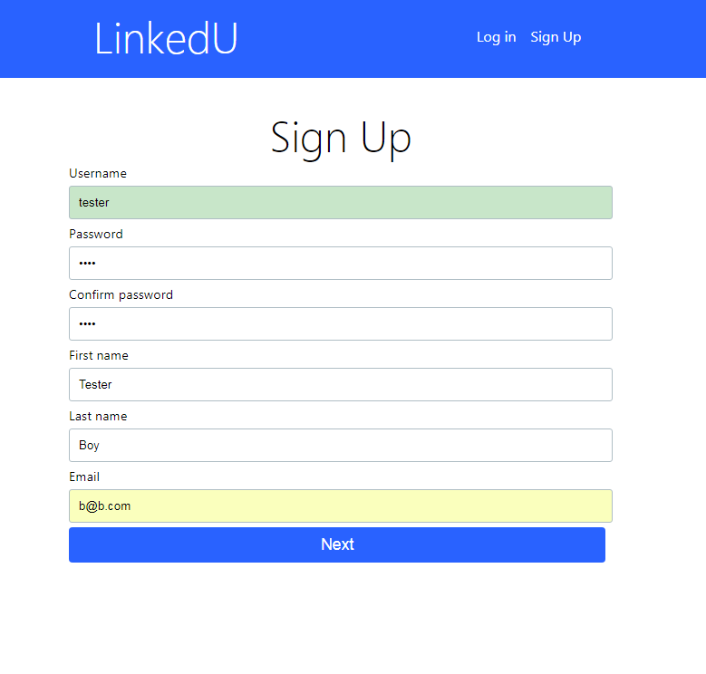

On initial page, click on Sign Up on navigation bar. Enter valid information and click Sign Up at the bottom. Then, Log In.

# Use Case 2: Log In

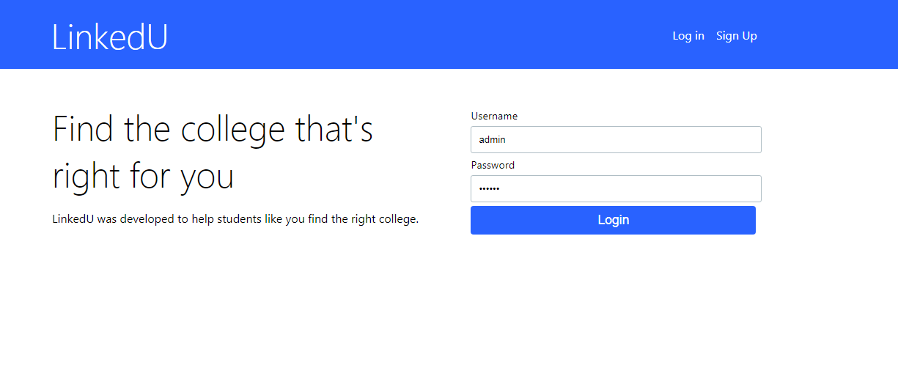

On initial page, enter username and password to log in

# Use Case 3: Post

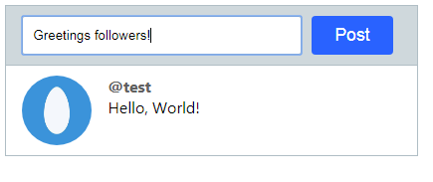

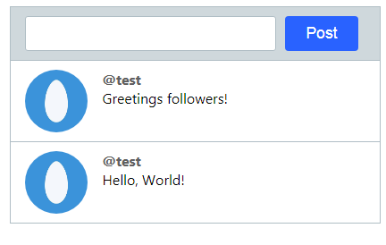

After login in, user is taken to Landing page. Click on Input field next to Post button. Enter some text and click Post. The Post will be added to the feed.

When the user logs back in, all feed will contain of his/her posts, sorted in chronological order.

# Use Case 4: Find university

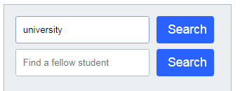

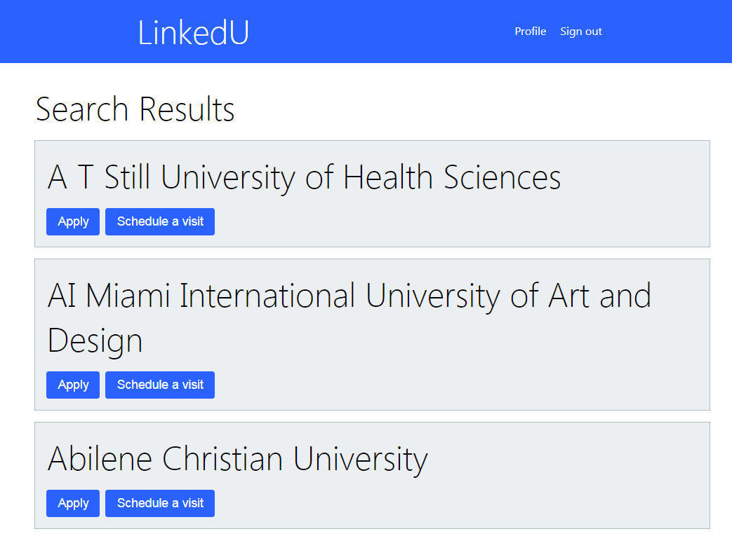

On landing page, click on the input field next with the placeholder ‘Find a university’. Enter the name of a university, (e.g. Illinois State) and click search. If a university is found in the DB, the user will be taken to an aggregated university search results page.

# Use Case 5: Apply for Admission

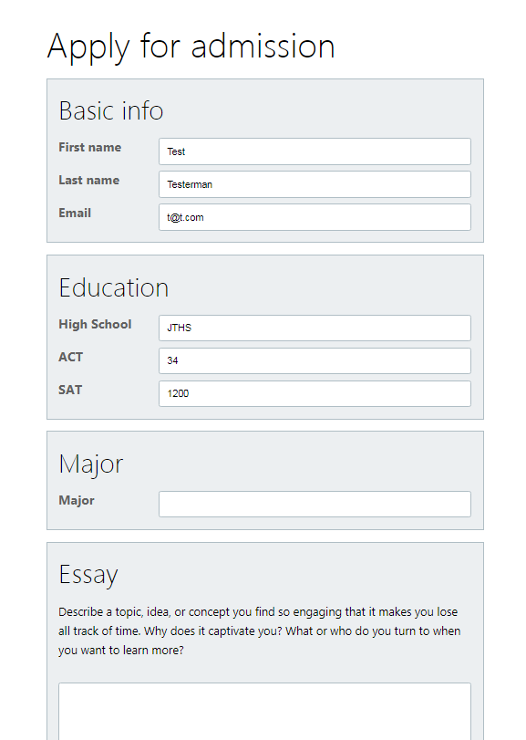

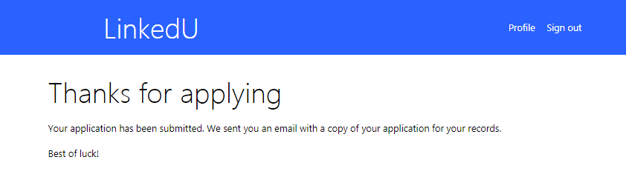

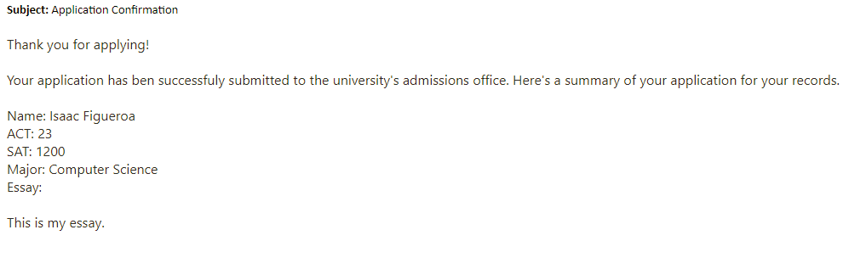

On the aggregated university search results page, underneath a university is an ‘apply’ button. Click this button to fill out a form with common application details. Upon submission, you will be redirected to a confirmation page and an email will be sent to your recorded email address.

# Use Case 6: Schedule a visit

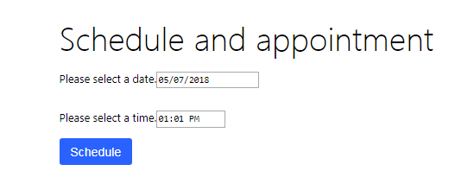

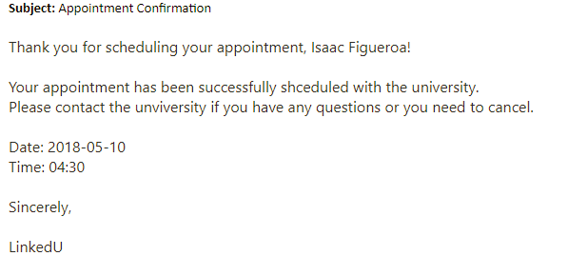

On the aggregated university search results page, underneath a university is an ‘Schedule a visit’ button. Click this button to record a date and time for your appointment. Upon submission, you will be redirected to the landing page and an email will be sent to your recorded email address.

# Use Case 7: Find a fellow student

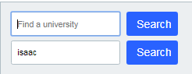

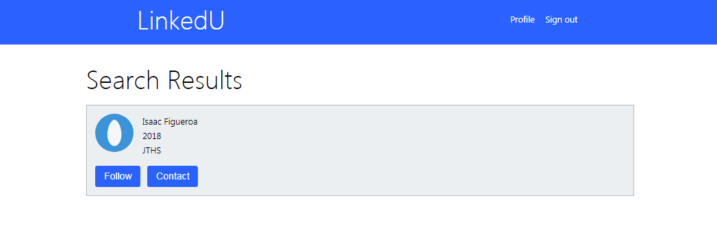

On landing page, click on the input field next with the placeholder ‘Find a fellow student’. Enter the name of student and click search. If a student is found in the DB with a name close to what you typed in, the user will be taken to an aggregated search results page.

# Use Case 8: Follow a fellow student

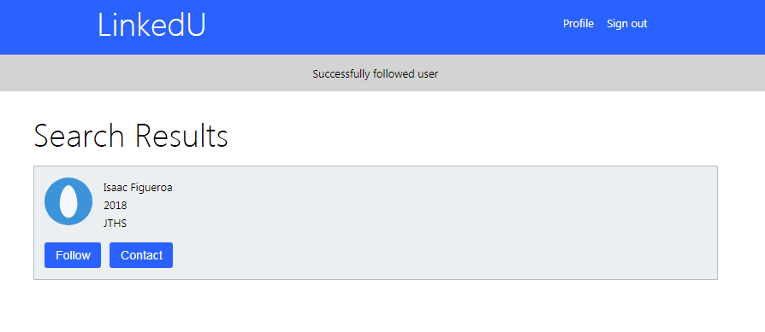

On the aggregated student search results page, underneath a user is a ‘follow’ button. Click this button to follow this user, whatever they post will be added to your feed.

# Use Case 9: Contact a fellow student

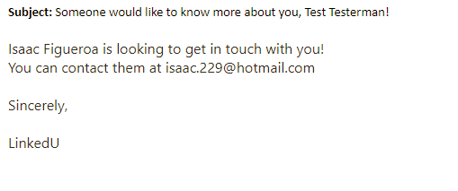

On the aggregated student search results page, underneath a user is a ‘contact’ button. Click this button to send an email to the student with your contact details.

# Use Case 10: Image Upload

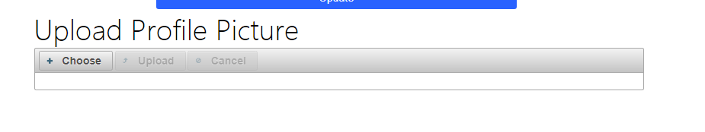

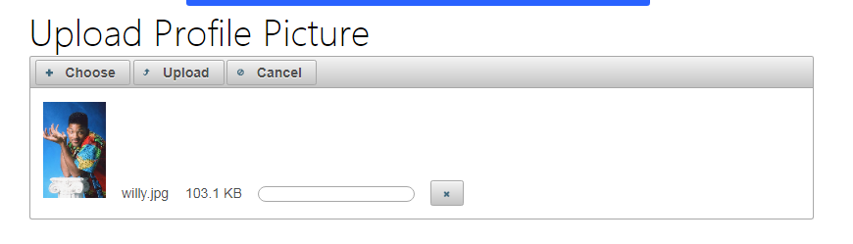

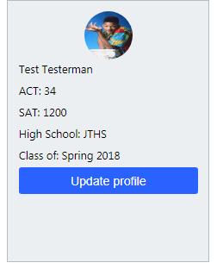

On landing page, go to Update profile. Then under Upload Profile picture, select an image and click upload. The image is then stored on the server. When we go back to the landing page, the profile image will be shown on the pane to the left.

# Use Case 11: Update Profile

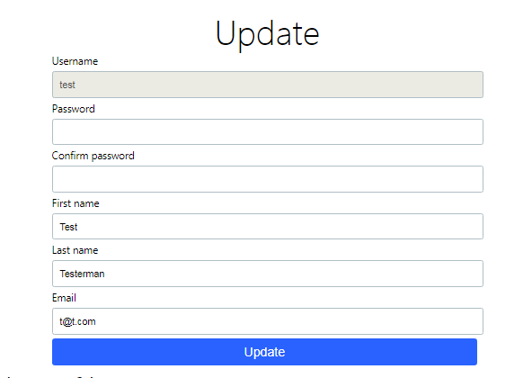

Once logged in, click on Update profile on the left pane. You may then re-enter the user’s information and click update profile.

# Use Case 12: User Admin

Log in as built in admin account:

User: admin

Password: secure

# Use Case 13: Remove featured university

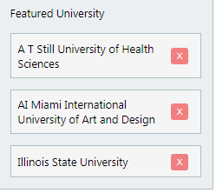

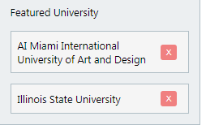

Once logged in as an admin, you will now see an orange ‘x’ next to each featured university. Click this button to remove the university from the featured list globally.

# Use Case 14: Add featured university

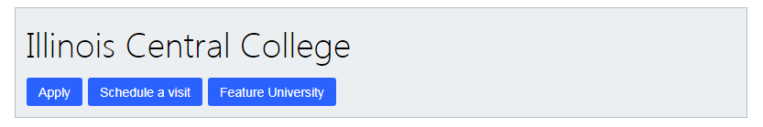

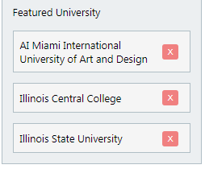

Once logged in as an admin, upon searching for universities, you will see a ‘Feature university’ button underneath each university search result. Click this button to add that university to the featured university column.

# Use Case 15: Promote User to Admin

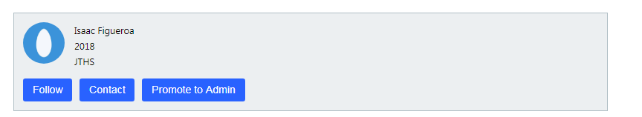

Once logged in, upon searching for users, you will see a ‘Promote to admin’ button underneath each student search result. Click this button to promote that user to admin.

# Use Case 16: Responsive Web Design

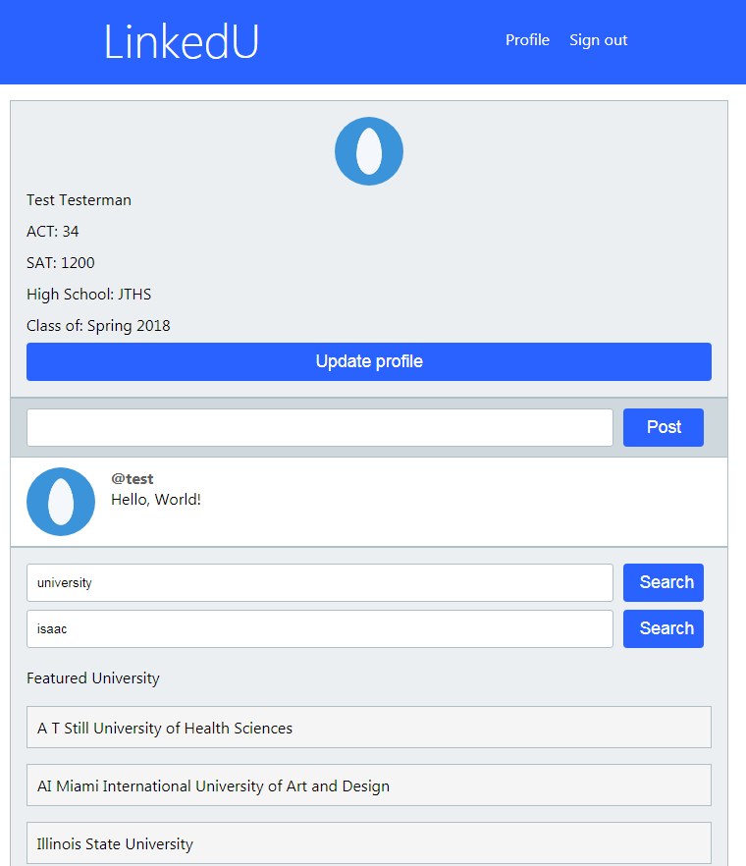

Once logged in, if your browsing device is small, the website view change to a mobile friendly version.